**Name : Pranav Telkikar**

**Roll No : 19102B0002**

**Branch/Div : CMPN/B**

**Subject : Audit Course Level 1 Task.**

**Project Name : ENGLISH FOOTBALL TRANSFERS AND TOP FANTASY PICKS**

|  |  |
| --- | --- |
| Front End Tools | HTML 5, CSS3 |
| Project Leader | Pranav Telkikar |
| Project Language | English |
| Country | India |
| Reference sites | www.w3schools.com |
| Github Repository Link | https://github.com/PranavTelkikar/AuditCourse1 |

**Project Description :**

The project is about the transfer market in football to be precise English football league .   
I have made a path of how a transfer of a player takes place from one club to other and also included the top 5 transfers in the news section along with the fantasy premier league top picks . Fantasy premier league is a game in which users select their favourite team players and get scored based on actual games and how the players picked perform.

**Screenshots:**

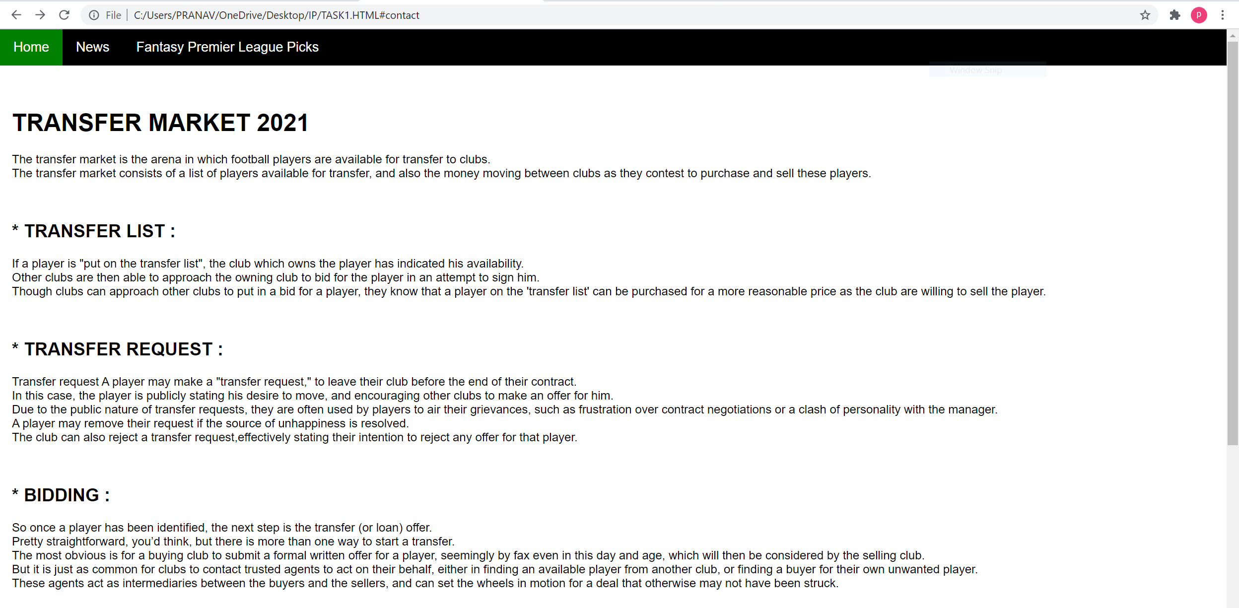

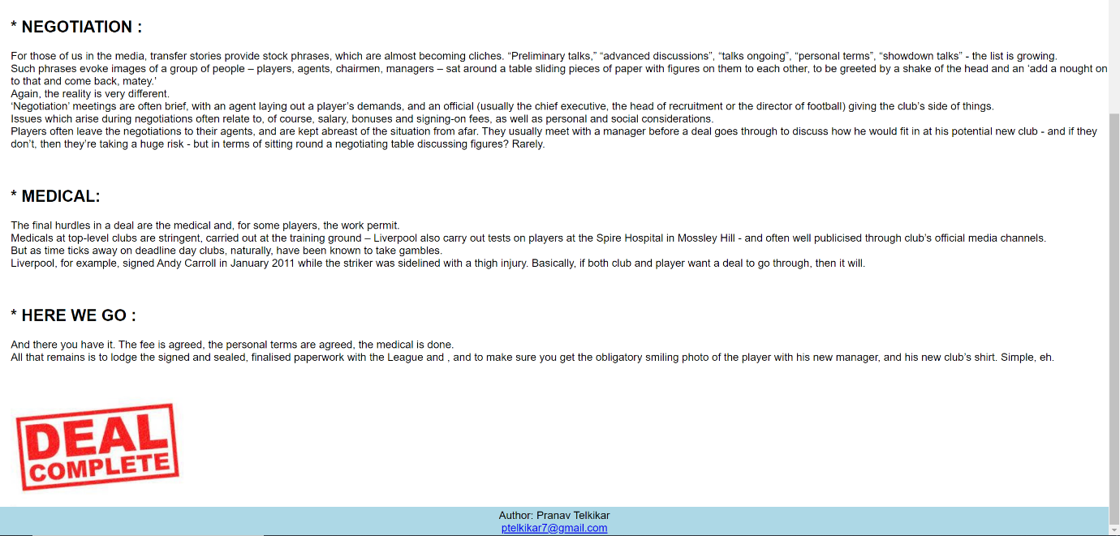

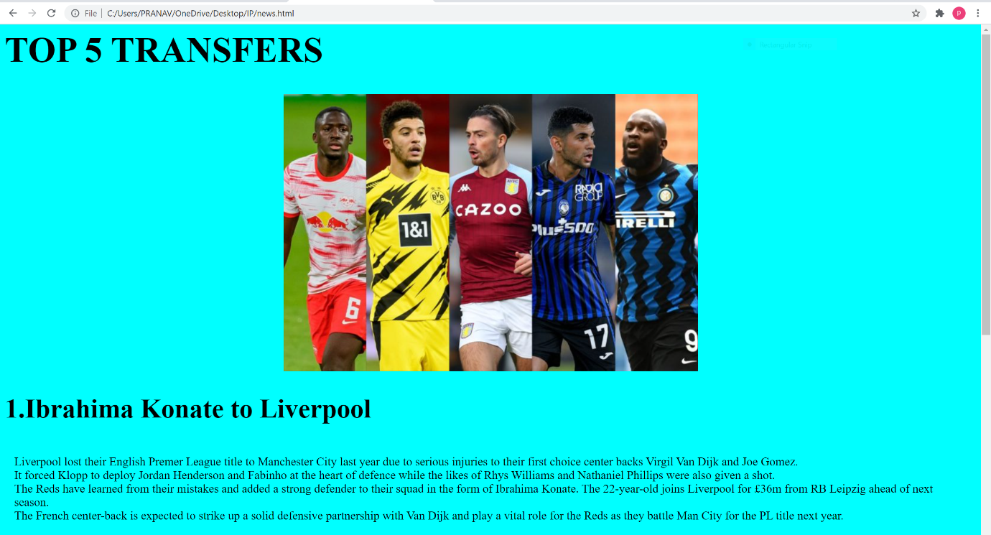



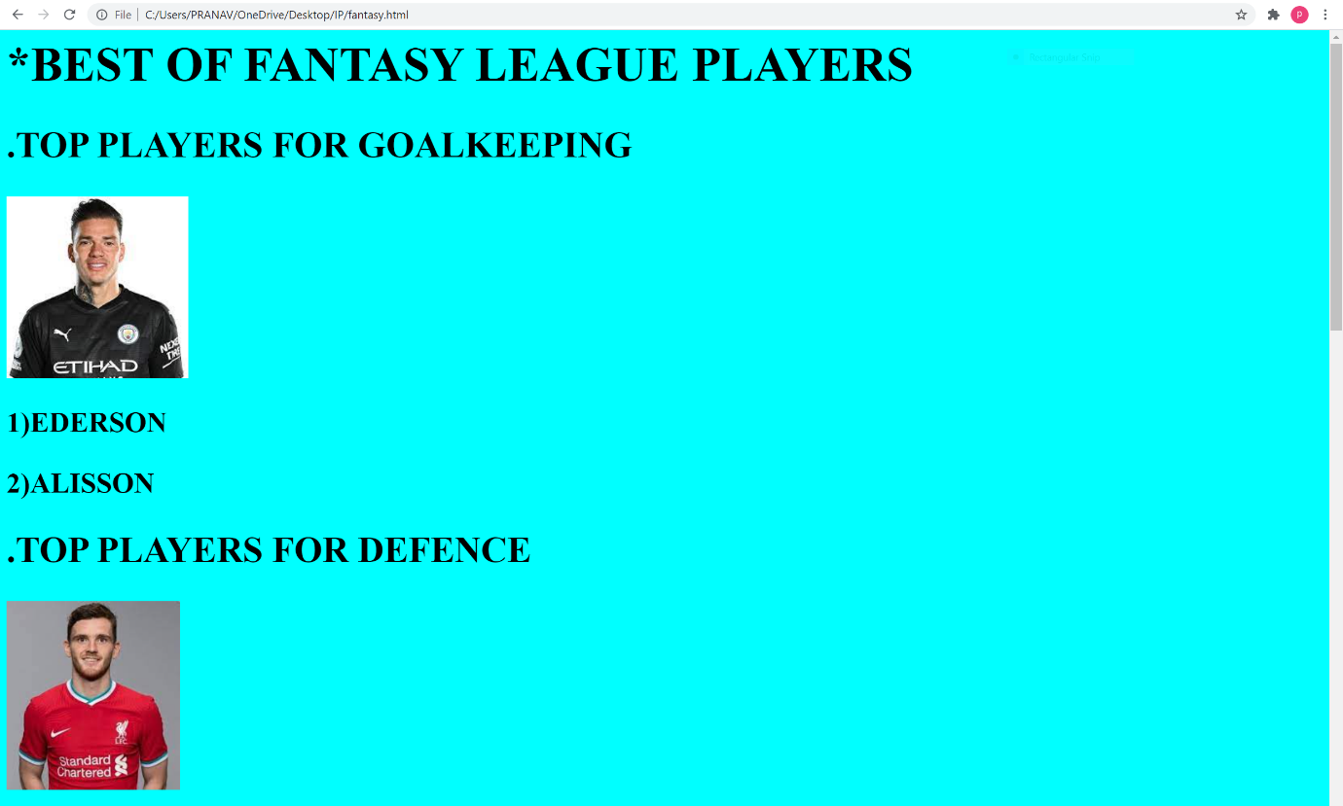





**Repository Link Here : https://github.com/PranavTelkikar/AuditCourse1**